WEB TECHNOLOGY LAB

EXP.NO: 9

AIM:
To develop an Online Help Desk Support System using HTML, CSS, and JavaScript that allows users to submit IT/technical support tickets with category and priority, view live ticket statistics, and update ticket status dynamically through a web browser.

ALGORITHM:
- Open a text editor or IDE (VS Code / Notepad++).
- Create a new file named index.html.
- Add the HTML skeleton with <head> and <body> sections.
- Inside <head>, write CSS to style the header, form card, statistics cards, ticket table, and colored status badges.
- In <body>, add a blue header with the application title and subtitle.
- Create the 'Submit a Support Ticket' card containing input fields for Full Name, Email Address, Issue Category (dropdown), Priority (dropdown), and Issue Description (textarea).
- Add a Submit Ticket button that invokes the submitTicket() JavaScript function on click.
- Create a 'Ticket Statistics' card showing three counters: Total Tickets, Open, and Resolved — updated dynamically.
- Create a 'Submitted Tickets' card with an HTML table containing columns: Ticket ID, Name, Category, Priority, Status, and Update Status.
- In the <script> block, declare a tickets array and a ticketCount variable initialised to 1.
- Write the submitTicket() function: validate all fields, generate a unique Ticket ID (TKT-001, TKT-002 …), push a ticket object into the array, then call renderTable() and updateStats().
- Write the changeStatus() function to locate a ticket by ID and update its status field.
- Write the updateStats() function to recount and display Total, Open, and Resolved ticket numbers.
- Write the renderTable() function to rebuild table rows dynamically with colour-coded priority text and status badges (Open = orange, In Progress = blue, Resolved = green).
- Save the file as index.html and open it in any web browser to run the application.

PROGRAM:

index.html

<!DOCTYPE html>
<html lang="en">
<head>
<meta charset="UTF-8">
<meta name="viewport" content="width=device-width, initial-scale=1.0">
<title>Online Help Desk Support System</title>
<style>
* { box-sizing: border-box; margin: 0; padding: 0; }
body {
font-family: Arial, sans-serif;
background: #f0f4f8; color: #333;
}
header {
background: #1565C0; color: white;
padding: 16px 24px;
}
header h1 { font-size: 22px; }
header p { font-size: 13px; opacity: 0.85; margin-top: 4px; }
.container {
max-width: 960px; margin: 30px auto; padding: 0 16px;
}
.card {
background: white; border-radius: 8px;
padding: 24px; margin-bottom: 24px;
box-shadow: 0 2px 6px rgba(0,0,0,0.08);
}
h2 {
color: #1565C0; font-size: 17px;
margin-bottom: 16px;
}
label {
display: block; font-size: 13px;
font-weight: bold; margin-bottom: 4px;
}
input, select, textarea {
width: 100%; padding: 9px 11px;
border: 1px solid #ccc; border-radius: 5px;
font-size: 13px; margin-bottom: 13px;
}
textarea { height: 90px; resize: vertical; }
.row { display: grid;
grid-template-columns: 1fr 1fr; gap: 16px; }
.submit-btn {
background: #1565C0; color: white;
border: none; border-radius: 5px;
padding: 10px 0; width: 100%;
font-size: 14px; cursor: pointer;
}
.submit-btn:hover { background: #0D47A1; }
#message { font-size: 13px; margin-top: 8px; }
.ok { color: #2E7D32; }
.err { color: #C62828; }
.stats {
display: grid;
grid-template-columns: repeat(3, 1fr);
gap: 12px; margin-bottom: 16px;
}
.stat {
background: #f0f4f8; border-radius: 6px;
padding: 12px; text-align: center;
}
.stat-num {
font-size: 26px; font-weight: bold;
color: #1565C0;
}
.stat-lbl { font-size: 12px; color: #666; }
table { width: 100%; border-collapse: collapse; }
th {
background: #1565C0; color: white;
padding: 10px 12px; text-align: left;
font-size: 13px;
}
td {
padding: 10px 12px;
border-bottom: 1px solid #eee;
font-size: 13px;
}
.badge {
display: inline-block; padding: 3px 10px;
border-radius: 12px; font-size: 11px;
font-weight: bold;
}
.Open { background:#FFF3E0; color:#E65100; }
.InProgress { background:#E3F2FD; color:#1565C0; }
.Resolved { background:#E8F5E9; color:#2E7D32; }
.High { color:#C62828; font-weight:bold; }
.Medium { color:#E65100; }
.Low { color:#2E7D32; }
.no-data {
text-align:center; color:#aaa;
padding:20px; font-size:13px;
}
</style>
</head>
<body>

<header>
<h1>Online Help Desk Support System</h1>
<p>Raise a ticket and track its resolution status</p>
</header>

<div class="container">

<!-- Ticket Submission Form -->
<div class="card">
<h2>Submit a Support Ticket</h2>
<label for="uname">Full Name</label>
<input type="text" id="uname" placeholder="Enter your full name">

<label for="uemail">Email Address</label>
<input type="email" id="uemail" placeholder="Enter your email">

<div class="row">
<div>
<label for="ucat">Issue Category</label>
<select id="ucat">
<option value="">-- Select Category --</option>
<option>Hardware</option>
<option>Software</option>
<option>Network</option>
<option>Account Access</option>
<option>Other</option>
</select>
</div>
<div>
<label for="upri">Priority</label>
<select id="upri">
<option value="">-- Select Priority --</option>
<option>Low</option>
<option>Medium</option>
<option>High</option>
</select>
</div>
</div>

<label for="udesc">Issue Description</label>
<textarea id="udesc"
placeholder="Describe your issue in detail..."></textarea>

<button class="submit-btn" onclick="submitTicket()">
Submit Ticket
</button>
<p id="message"></p>
</div>

<!-- Statistics Dashboard -->
<div class="card">
<h2>Ticket Statistics</h2>
<div class="stats">
<div class="stat">
<div class="stat-num" id="totalCount">0</div>
<div class="stat-lbl">Total Tickets</div>
</div>
<div class="stat">
<div class="stat-num" id="openCount"
style="color:#E65100;">0</div>
<div class="stat-lbl">Open</div>
</div>
<div class="stat">
<div class="stat-num" id="resolvedCount"
style="color:#2E7D32;">0</div>
<div class="stat-lbl">Resolved</div>
</div>
</div>
</div>

<!-- Ticket Dashboard Table -->
<div class="card">
<h2>Submitted Tickets</h2>
<table>
<thead>
<tr>
<th>Ticket ID</th>
<th>Name</th>
<th>Category</th>
<th>Priority</th>
<th>Status</th>
<th>Update Status</th>
</tr>
</thead>
<tbody id="ticketTable">
<tr>
<td colspan="6" class="no-data">
No tickets submitted yet.
</td>
</tr>
</tbody>
</table>
</div>

</div>

<script>
let tickets = [];
let ticketCount = 1;

function submitTicket() {
const name = document.getElementById('uname').value.trim();
const email = document.getElementById('uemail').value.trim();
const cat = document.getElementById('ucat').value;
const pri = document.getElementById('upri').value;
const desc = document.getElementById('udesc').value.trim();
const msg = document.getElementById('message');

if (!name || !email || !cat || !pri || !desc) {
msg.className = 'err';
msg.textContent = 'Please fill in all fields before submitting.';
return;
}

const ticket = {
id : 'TKT-' + String(ticketCount++).padStart(3, '0'),
name, email,
category : cat,
priority : pri,
status : 'Open'
};

tickets.push(ticket);
renderTable();
updateStats();

msg.className = 'ok';
msg.textContent =
'Ticket submitted successfully! Your ID: ' + ticket.id;

['uname','uemail','ucat','upri','udesc']
.forEach(id => document.getElementById(id).value = '');
}

function changeStatus(id, val) {
const t = tickets.find(x => x.id === id);
if (t) { t.status = val; renderTable(); updateStats(); }
}

function updateStats() {
document.getElementById('totalCount').textContent =
tickets.length;
document.getElementById('openCount').textContent =
tickets.filter(t =>
t.status === 'Open' || t.status === 'InProgress').length;
document.getElementById('resolvedCount').textContent =
tickets.filter(t => t.status === 'Resolved').length;
}

function renderTable() {
const tbody = document.getElementById('ticketTable');
if (!tickets.length) {
tbody.innerHTML =
'<tr><td colspan="6" class="no-data">No tickets submitted yet.</td></tr>';
return;
}
tbody.innerHTML = [...tickets].reverse().map(t => {
const sc = t.status.replace(' ','');
return `<tr>
<td>${t.id}</td>
<td>${t.name}</td>
<td>${t.category}</td>
<td class="${t.priority}">${t.priority}</td>
<td>
<span class="badge ${sc}">${t.status}</span>
</td>
<td>
<select style="width:auto;padding:4px 6px;font-size:12px;"
onchange="changeStatus('${t.id}',this.value)">
<option ${t.status==='Open'?'selected':''}>Open</option>
<option ${t.status==='In Progress'?'selected':''}>
In Progress</option>
<option ${t.status==='Resolved'?'selected':''}>
Resolved</option>
</select>
</td>
</tr>`;
}).join('');
}
</script>
</body>
</html>

OUTPUT:

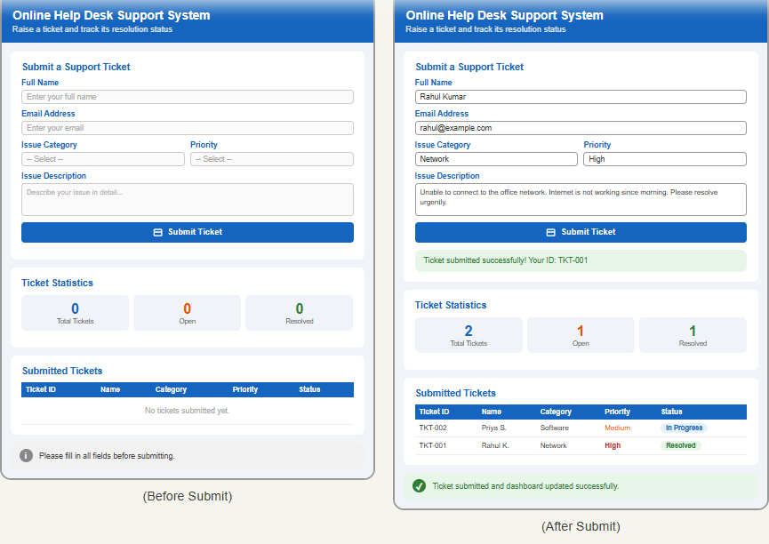

RESULT:
The Online Help Desk Support System was successfully developed and executed using HTML, CSS, and JavaScript. Users can submit support tickets with category and priority levels, monitor real-time statistics for Total, Open, and Resolved tickets, and dynamically update each ticket's status between Open, In Progress, and Resolved states.

